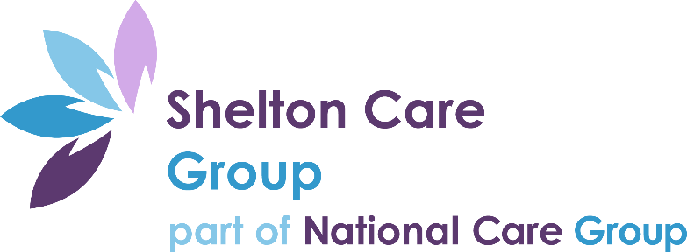

Gender Pay Gap Report 2021

Overview

This report highlights the gender pay gap at Shelton Care Group between males and females. This is broken down by hourly pay and bonus payments.

The gender pay gap measures the difference of male and female’s average pay across the business, regardless of their role.

The data within this report is based on 351 employees that were employed by Shelton Care Group on the snapshot date of 5th April 2021. The bonus data is based on the dates between 6th April 2020 and 5th April 2021.

Shelton Care Group is part of a wider company National Care Group who provides care to adults with a range of disabilities and needs.

I can confirm that the data provided in this report is accurate.

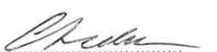

Claire Leake
People Director – National Care Group

This Year’s Findings
0%
Received a bonus payment
£9.48
Average hourly rate
76
Male employees
275
Female employees
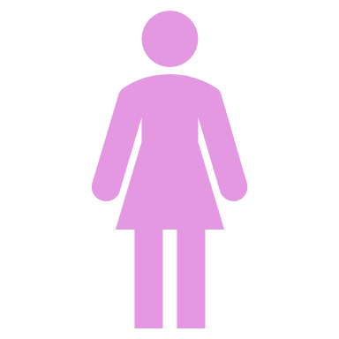
£9.94
Average hourly rate
1%
Received a bonus payment

The mean gender pay gap (hourly pay)

The difference between the mean hourly pay rate for both males and females as a percentage of male’s pay at Shelton Care is -4.80%. This is considerably less than the UK’s national average of 15.4.

This highlights that there is a slight pay gap where our female employees are at an advantage, as females on average receive 4.80% more than male employees at Shelton.

This is not a cause for concern for male employees, as the main reason for this is as 78% of Shelton’s headcount is made up of female employees and the majority of Shelton’s senior employees are female too.

Out of 351 employees, there are 50 senior employees (this includes roles from a Senior Support Worker and above). The breakdown of male/female split of senior employees is:-

Male | Female
22% | 78%

The median gender pay gap (hourly pay)

This defines and compares the difference between the middle hourly rate of pay for both males and females.

Shelton Care’s median gender pay gap is 0% meaning that there is no gap when comparing as a median figure.

The mean gender pay gap (bonuses)

This defines the difference between the mean bonus amount for both males and females as a percentage of male’s bonus payments. This year Shelton Care’s was at 100%.

The median gender pay gap (bonuses)

This defines and compares the difference between the middle bonus amount for both males and females. This year Shelton Care’s was at 100%.
The reason for both bonus pay gaps being 100%, is because the management team within Shelton Care were the only employees to receive bonuses between the snapshot dates in 2020 and 2021. The management team during that time were all female employees.

As a result of this, our figures show that 1% of females received a bonus and no males received a bonus.

Therefore, out of all the employees who received a bonus during the snapshot dates, 100% of them were female.

The proportion of males and females in each pay quartile
All employees were put in order of hourly pay (lowest to highest) and then split into 4 even quartiles. The pay quartiles are as follows:-

- Lower quartile – 88 employees
- Lower middle quartile – 88 employees
- Upper middle quartile – 88 employees
- Upper quartile – 87 employees

Comparing to Last Year’s Findings

 | Shelton  Care Group 2020 | Shelton  Care Group 2020 | Comments
Mean Gender Pay Gap (Hourly Rate) | -1.65% | -4.80% | The mean gender pay gap has decreased since last year in favour of female employees, meaning that on average females receive 4.80% more per hour than males.
Median Gender Pay Gap (Hourly Rate) | 0.00% | 0.00% | The median gender pay gap has remained the same as last year’s and there is still no difference.
Mean Gender Pay Gap (Bonus) | N/A | N/A | We are not able to compare to last year’s data, as there were no male employees to receive a bonus.
Median Gender Pay Gap (Bonus) | N/A | N/A
Average Hourly Rate for Males at Shelton | £8.43ph | £9.48 | Compared to last year both male and females’ average hourly rates have increased  Last year there was a difference of 14p to males and females’ average hourly rate. This year this has increased by 32p to 46p difference,
Average Hourly Rate for Females at Shelton | £8.57ph | £9.94
Number of Employees at Shelton | 288 | 351 | During the year the headcount has increased by 21.87%
Number of Males Employed by Shelton | 58 | 76 | The male headcount has increased by 18 since last year.
Number of Females Employed by Shelton | 230 | 275 | The female headcount has increased by 45 since last year.

Changes Since Last Year

Since last year’s report, the organisation has implemented the following which may have had an impact on the gender pay gap between males and females:-
- Targetted recruitment activity to increase overall number of new employees
- Continued to promote opportunities for career development and progression
- Encouraged Managers and provided them with the new and improved tools to carry out regular and effective supervisions.
- Maintained our commitment to equal opportunities across the business.
- Maintained our commitment to the continuous learning and development opportunities for our colleagues.
- Developed the job vacancies page on the company intranet so it provides a live vacancies list across all companies under National Care Group, so employees have the first opportunity to apply for new vacancies.
- Continued to offer flexible working opportunities across the business for all employees.

Future Improvements

National Care Group and Shelton Care intends to implement the following over the next 12 months which may impact the gender pay gap:-
- Utilise the apprenticeship levy to train and develop more employees internally into leadership positions.
- Continued focus on wellbeing initiatives to fully support employees to promote work life balance and build resilience.
- Deliver leadership programme to provide our future managers with the essential skills to eventually move into more senior roles.
- Create career pathways for all levels of employees from Support Worker upwards.
- Recruitment initiatives to ensure that a more diverse prospective candidate pool is reached.

References

Office for National Statistics, Gender Pay Gap in the UK 2021 –
Gender pay gap in the UK - Office for National Statistics (ons.gov.uk)

